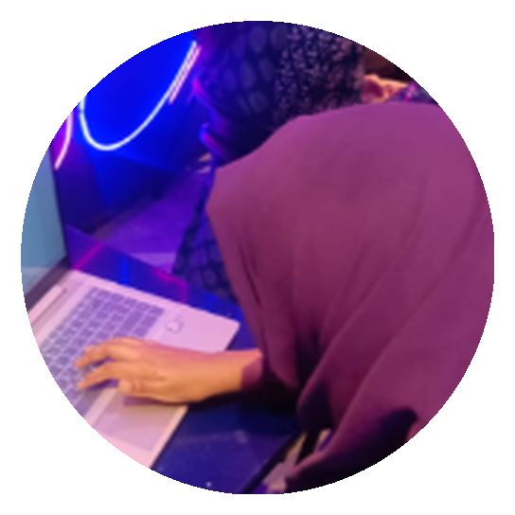  RAMEEN JAVED  AI STUDENT | SOCIAL MEDIA MANAGER  ☎ 0313-0421549  ✉ rameenj012@gmail.com  ⌖ UET Lahore, Pakistan  EDUCATION  BS Artificial Intelligence  UET Lahore — 3rd Semester  FSc Pre-Engineering  Superior College — 2023 – 2025 |  | ■ ABOUT ME  A third-semester BS Artificial Intelligence student at UET Lahore, combining a strong technical foundation in programming and object-oriented development with hands-on creative experience in video editing, graphic design, and social media management. Skilled at managing multiple responsibilities and meeting deadlines across academic projects, remote internships, and content production.  ■ WORK EXPERIENCE  Remote Intern — AI/ML & Web Development  - Contributed to AI/ML and web development tasks in a remote internship.  - Managed multiple tasks efficiently while consistently meeting project deadlines.  Social Media Manager — Remote  - Managed social media content, campaigns, and multiple tasks in parallel.  - Ensured timely, consistent output while coordinating tasks under tight deadlines.  Projects  ■ SKILLS SUMMARY  Video Editing  C++ (OOP)  Graphic Designing  Python  HTML & CSS  Reference:  On Demand
  - Hospital Management System (C)  - Survey Form (HTML/CSS)  - Workflow Automation (n8n) | - Digital Voting System (C++ OOP)  - Water Filtration Plant Website  - MS Word, Excel & PowerPoint

